**KEY WORDS :**

**Convolutional Neural Network –**

A convolutional neural network (CNN or ConvNet) is one of the most popular algorithms for deep learning, a type of machine learning in which a model learns to perform classification tasks directly from images, video, text, or sound.

**Deep belief network -**

In machine learning, a **deep belief network** (**DBN**) is a generative graphical model, or alternatively a class of deep neural network, composed of multiple layers of latent variables ("hidden units"), with connections between the layers but not between units within each layer.

**Artificial neural networks-**

A neural network is a computing model whose layered structure resembles the networked structure of neurons in the brain, with layers of connected nodes. A neural network can learn from data so it can be trained to recognize patterns, classify data, and forecast future events.

**Feature extraction-**

Feature extraction for compact representation of image data in computer vision. Feature extraction a type of dimensionality reduction that efficiently represents interesting parts of an image as a compact feature vector. This approach is useful when image sizes are large and a reduced feature representation is required to quickly complete tasks such as image matching and retrieval.

**Strong artificial intelligence :-**

Strong Artificial Intelligence (AI) is a theoretical form of machine intelligence that is equal to human intelligence. Key characteristics of Strong AI include the ability to reason, solve puzzles, make judgments, plan, learn, and communicate. It should also have consciousness, objective thoughts, self-awareness, sentience, and sapience.

**Weak artificial intelligence :-**

Weak AI, or Narrow AI, is a machine intelligence that is limited to a specific or narrow area. Weak Artificial intelligence (AI) simulates human cognition and benefits mankind by automating time-consuming tasks and by analysing data in ways that humans sometimes can’t.

**DATA SCIENCE**

## What is Data Science?

* Data science provides meaningful information based on large amounts of complex data or big data.
* 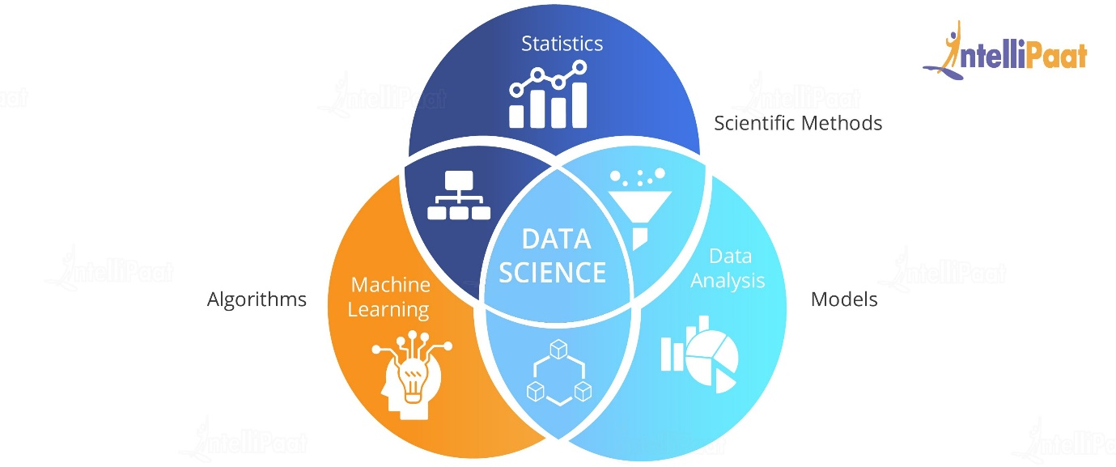The principal purpose of Data Science is to find patterns within data. It uses various statistical techniques to analyse and draw insights from the data. From data extraction, wrangling and pre-processing, a Data Scientist must scrutinize the data thoroughly.

### How Data Science Is Applied

* Data science incorporates tools from multiple disciplines to gather a data set, process, and derive insights from the data set, extract meaningful data from the set, and interpret it for decision-making purposes.
* The disciplinary areas that make up the data science field include mining, statistics, machine learning, analytics, and programming.

**MACHINE LEARNING:**

Machine Learning is the field of study that gives computers the capability to learn without being explicitly programmed. ML is one of the most exciting technologies that one would have ever come across. As it is evident from the name, it gives the computer that makes it more similar to humans: **The ability to learn**. Machine learning is actively being used today, perhaps in many more places than one would expect.

Types of learning:

**1. Supervised learning**

**2. Unsupervised learning**

**3. Semi-supervised learning**

**4. Reinforcement**

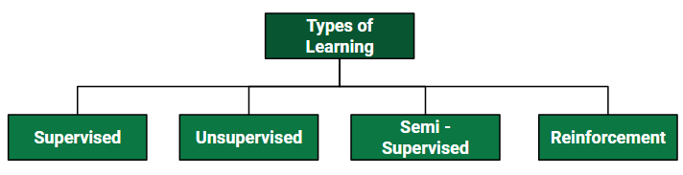

**1.Supervised learning :**

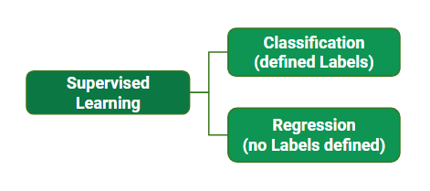When an algorithm learns from example data and associated target responses that can consist of numeric values or string labels, such as classes or tags, in order to later predict the correct response when posed with new examples comes under the category of Supervised learning.

**Types of Supervised Learning:**

* **Classification :**

Classification is a technique that aims to reproduce class assignments. It can predict the response value and the data is separated into “classes”. Classification problem is when the output variable is a category, such as “Red” or “Blue” or “disease” or “no disease”.

**Example:**

1. Gmail classifies mails in more than one classes like social, promotions, updates, forum.
2. Recognition of a type of car in a photo.

* **Regression :**

Regression is a technique that aims to reproduce the output value. It is a supervised learning task where output is having continuous value. The goal here is to predict a value as much closer to actual output value as our model can and then evaluation is done by calculating error value. The smaller the error the greater the accuracy of our regression model.

**Example**:

1. A regression problem is when the output variable is a real value, such as “dollars” or “weight”.

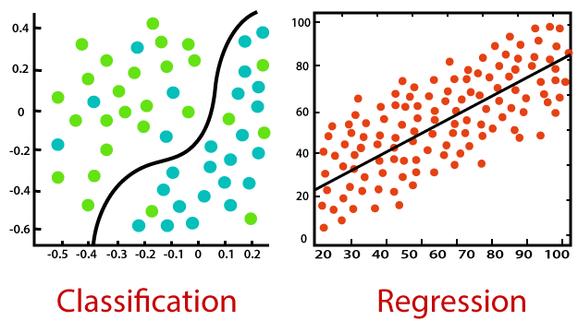

**Example of Supervised Learning Algorithms:**

* Linear Regression
* Nearest Neighbour
* Gaussian Naive Bayes
* Decision Trees
* Support Vector Machine (SVM)
* Random Forest

1. **Unsupervised learning :**

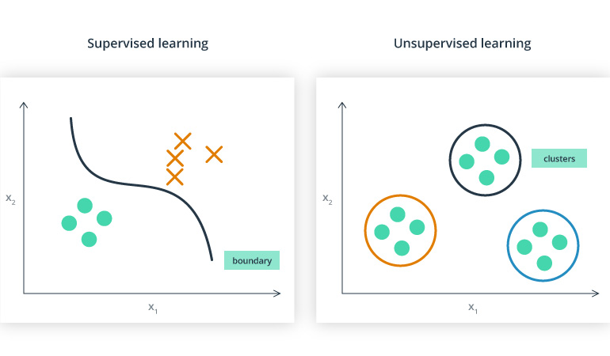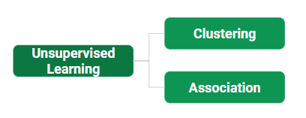Unsupervised learning is the training of machine using information that is neither classified nor labelled and allowing the algorithm to act on that information without guidance. Here the task of machine is to group unsorted information according to similarities, patterns and differences without any prior training of data.

**Types of unsupervised learning**

Unsupervised learning classified into two categories of algorithms:

* **Clustering**:

A clustering problem is where you want to discover the inherent groupings in the data, such as grouping customers by purchasing behaviour.

**Clustering methods:**

1. Density based method

2. Hierarchical based method

3. Partitioning method

4. Grid based method

* **Association**:

This technique is a rule based ML technique which finds out some very useful relations between parameters of a large data set. For e.g. shopping stores use algorithms based on this technique to find out relationship between sale of one product w.r.t to others sale based on customer behavior.

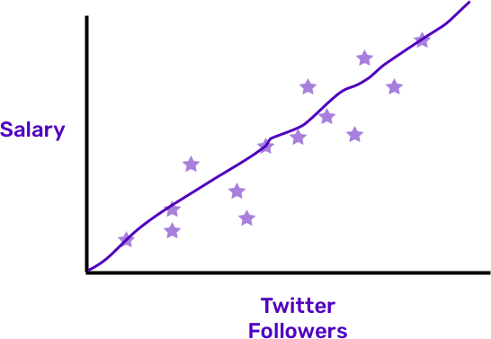

The stars are data points, and machine learning works on creating a line that explains how the input and outcomes are related. But in unsupervised learning, there are no outcomes! We’re just looking to analyse in the input, which is our Twitter followers. There is no salary, or Y, involved at all. Just like there not being an answer key for the test.

**Examples of unsupervised learning algorithms are:**

* k-means for clustering problems.
* Apriori algorithm for association rule learning problems.
* **Reinforcement learning :**

When you present the algorithm with examples that lack labels, as in unsupervised learning. Reinforcement learning is all about making decisions sequentially. In simple words we can say that the output depends on the state of the current input and the next input depends on the output of the previous input.

In Reinforcement learning decision is dependent, So we give labels to sequences of dependent decisions. Example: Chess game.

* **Semi-supervised learning :**

  semi-supervised learning is intermediate between supervised learning and unsupervised learning. In this type of learning, the algorithm is trained upon a combination of labeled and unlabeled data.

**Examples of semi-supervised algorithms:**

1. Graph based algorithm
2. Multiview algorithm

**Note :** one may imagine the three types of learning algorithms as Supervised learning where a student is under the supervision of a teacher at both home and school, Unsupervised learning where a student has to figure out a concept himself and Semi-Supervised learning where a teacher teaches a few concepts in class and gives questions as homework which are based on similar concepts.

**ALGORITHMS**

**1. LINEAR REGRESSION:**

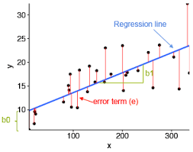Linear regression is an important technique. Its basis is illustrated here, and various derived values such as the standard deviation from regression and the slope of the relationship between two variables. It is a linear approach to modelling the relationship between a scalar response (or  Dependent variables) and one or more Exploratory variables (or Independent variables).

**There are two main types:**

* 1. Simple Regression
  2. Multivariable Regression

**1. Simple Regression:**

When we have a single input attribute (x) and we want to use linear regression, this is called simple linear regression. One is predictor or independent variable and other is response or dependent variable.

y=mx+b

**2.Multiple Linear Regression:**

If we had multiple input attributes (e.g. x1, x2, x3, etc.) This would be called multiple linear regression.

*yi*​=*β*0​+*β*1​*xi*1​+*β*2​*xi*2​+...+*βp*​*xip*​+*ϵ*

**LOGISTIC REGRESSION:**

​ **Logistic Regression Assumptions:**

* Binary logistic regression requires the dependent variable to be binary.
* For a binary regression, the factor level 1 of the dependent variable should represent the desired outcome.
* Only the meaningful variables should be included.
* The independent variables should be independent of each other. That is, the model should have little or no multicollinearity.
* 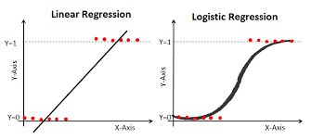The independent variables are linearly related to the log odds.

**DECISION TREE:** Decision tree is the most powerful and popular tool for classification and prediction. A Decision tree is a flowchart like tree structure, where each internal node denotes a test on an attribute, each branch represents an outcome of the test, and each leaf node (terminal node) holds a class label

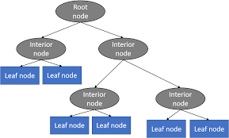

**RANDOM FOREST REGRESSION:**

The random forest is a model made up of many decision trees. Rather than just simply averaging the prediction of trees (which we could call a “forest”), this model uses two key concepts that gives it the name random:

1. Random sampling of training data points when building trees
2. Random subsets of features considered when splitting nodes

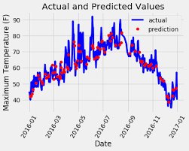

**SUPPORT VECTOR MACHINE(SVM):**

Support vector machine is another simple algorithm that every machine learning expert should have in his/her arsenal. Support vector machine is highly preferred by many as it produces significant accuracy with less computation power. Support Vector Machine, abbreviated as classification objective.

**What is Support Vector Machine?**

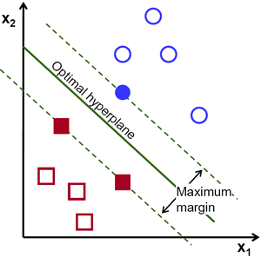The objective of the support vector machine algorithm is to find a hyperplane in an N-dimensional space(N — the number of features) that distinctly classifies the data points.

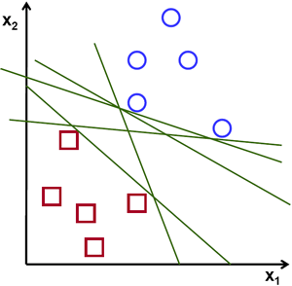

To separate the two classes of data points, there are many possible hyperplanes that could be chosen. Our objective is to find a plane that has the maximum margin, i.e the maximum distance between data points of both classes. Maximizing the margin distance provides some reinforcement so that future data points can be classified with more confidence.

**Hyperplanes -**

Hyperplanes are decision boundaries that help classify the data points. Data points falling on either side of the hyperplane can be attributed to different classes. Also, the dimension of the hyperplane depends upon the number of features. If the number of input features is 2, then the hyperplane is just a line. If the number of input features is 3, then the hyperplane becomes a two-dimensional plane. It becomes difficult to imagine when the number of features exceeds 3.

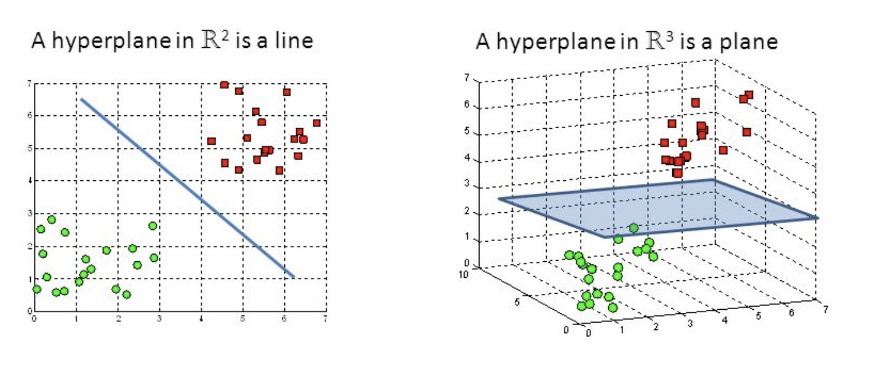

Fig : Hyperplanes in 2D and 3D feature space

**Support Vectors -**

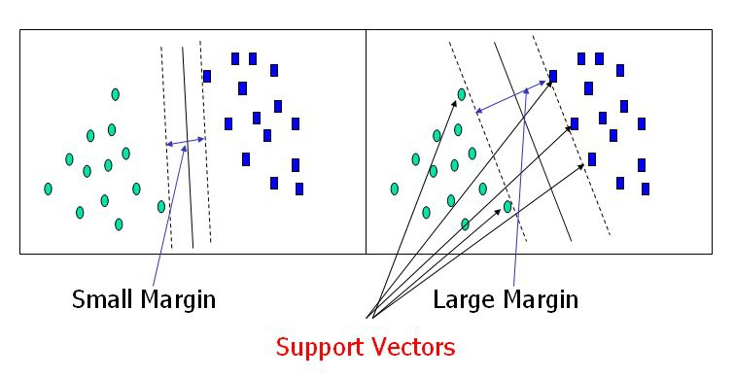Support vectors are data points that are closer to the hyperplane and influence the position and orientation of the hyperplane. Using these support vectors, we maximize the margin of the classifier. Deleting the support vectors will change the position of the hyperplane. These are the points that help us build our SVM.

**Data visualization:** Data visualization is the graphical representation of information and data. By using visual elements like charts, graphs, and maps, data visualization tools provide an accessible way to see and understand trends, outliers, and patterns in data

**DEEP LEARNING (DL)**

Deep learning is a machine learning technique that teaches computers to do what comes naturally to humans: learn by example. Deep learning is a key technology behind driverless cars, enabling them to recognize a stop sign, or to distinguish a pedestrian from a lamppost.

**Case Study on Harley Davidson**

The place we are in today is where it is difficult to break through traditional marketing. For a business like – Harley Davidson NYC, Albert (an artificial intelligence-powered robot) has a lot of appeal. Powered by machine learning and artificial intelligence, robots are writing news stories, working in hotels, managing traffic, and even running McDonald’s.

Albert can be applied to various marketing channels including social media and email. The software predicts which consumers are most likely to convert and adjusts personal creative copies on its own.

Harley Davidson is the only brand to make use of Albert. The company analyzed customer data to determine the behavior of previous customers whose actions were positive in terms of purchasing and spending more than the average amount of time on browsing through the website. With this information, Albert created segments of customers and scaled up the test campaigns accordingly.

Results show that Harley Davidson increased its sales by 40% with the use of Albert. The brand also had a 2,930% increase in leads, with 50% of those from high converting ‘lookalikes’ identified by artificial intelligence and machine learning.

**INTERNET OF THINGS(IOT)**

In a nutshell, the Internet of Things is the concept of connecting any device (so long as it has an on/off switch) to the Internet and to other connected devices. The IoT is a giant network of connected things and people – all of which collect and share data about the way they are used and about the environment around them.

**ARTIFICIAL INTELLIGENCE (AI)**

Artificial intelligence (AI) refers to the simulation of human intelligence in machines that are programmed to think like humans and mimic their actions. The term may also be applied to any machine that exhibits traits associated with a human mind such as learning and problem-solving.

**Strong artificial intelligence :-**

* Strong Artificial Intelligence (AI) is a theoretical form of machine intelligence that is equal to human intelligence. Key characteristics of Strong AI include the ability to reason, solve puzzles, make judgments, plan, learn, and communicate. It should also have consciousness, objective thoughts, self-awareness, sentience, and sapience.

**Weak artificial intelligence :-**

* Weak AI, or Narrow AI, is a machine intelligence that is limited to a specific or narrow area. Weak Artificial intelligence (AI) simulates human cognition and benefits mankind by automating time-consuming tasks and by analyzing data in ways that humans sometimes can’t.